Create Your First Azure Windows Virtual Machine

Difficulty: Beginner Estimated Time : 10 minutes

*In this scenario you will learn how to deploy an Azure Virtual Machine using the*Azure Portal

Azure Virtual Machines are a fast way to deploy VM’s with a per-second billing model, making it ideal for short, ad-hoc, workloads.

If you don't have an Azure subscription, create a free account before you begin.

**Create virtual machine**

1. Log in to Azure
2. Type **virtual machines** in the search.
3. Under **Services**, select **Virtual machines**.
4. In the **Virtual machines** page, select **Create** then **Virtual machine**.
5. In the **Basics** tab, under **Project details**, make sure the correct subscription is selected and then choose to **Create new** resource group. Type *myResourceGroup* for the name.

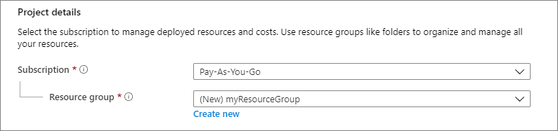

1. Under **Instance details**, type myVM for the **Virtual machine name** and choose East US for your **Region**. Choose Windows Server 2019 Datacenter for the **Image** and Standard_DS1_v2 for the **Size**. Leave the other defaults.

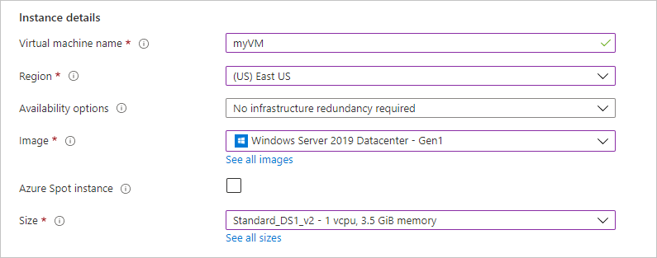

1. Under Administrator account, provide a username, such as azureuser and a password. The password must be at least 12 characters long and meet the defined complexity requirements.

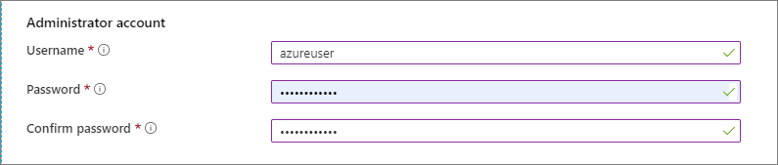

1. Under Inbound port rules, choose Allow selected ports and then select RDP (3389) and HTTP (80) from the drop-down.

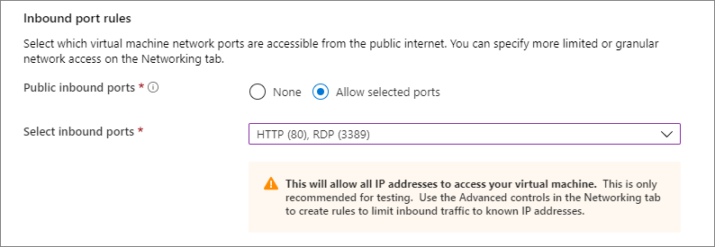

1. Leave the remaining defaults and then select the Review + create button at the bottom of the page.

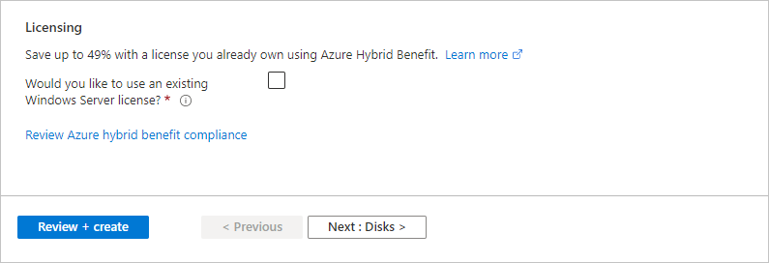

1. After validation runs, select the Create button at the bottom of the page.

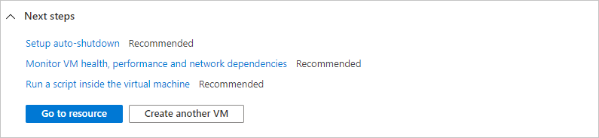

1. After deployment is complete, select Go to resource.

Connect to the newly created VM.

Create a remote desktop connection to the virtual machine. These directions tell you how to connect to your VM from a Windows computer. Note: On a Mac, you need an RDP client such as this Remote Desktop Client from the Mac App Store.

1. On the overview page for your virtual machine, select the Connect button then select RDP.
2. Create a remote desktop connection to the virtual machine. These directions tell you how to connect to your VM from a Windows computer. On a Mac, you need an RDP client such as this Remote Desktop Client from the Mac App Store.
3. On the overview page for your virtual machine, select the Connect button then select RDP.

To see your VM in action, install the IIS web server. Open a PowerShell prompt on the VM and run the following command: Install-WindowsFeature -name Web-Server -IncludeManagementTools

In the portal, select the VM and in the overview of the VM, hover over the IP address to show Copy to clipboard. Copy the IP address and paste it into a browser tab. The default IIS welcome page will open, and should look like this:

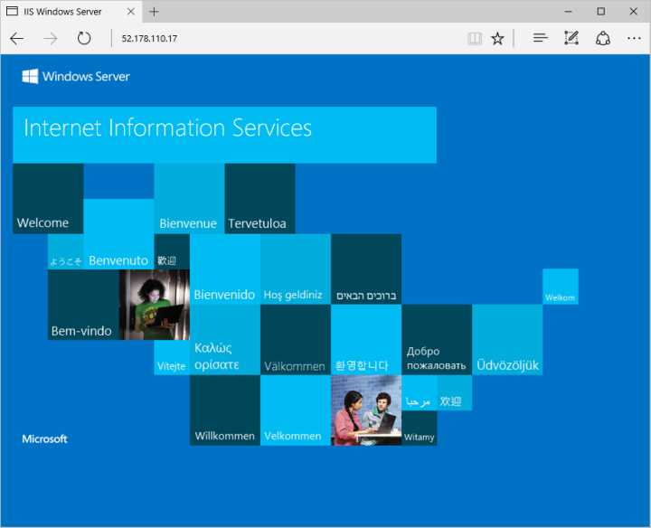

When no longer needed, you can delete the resource group, virtual machine, and all related resources.

Go to the resource group for the virtual machine, then select Delete resource group. Confirm the name of the resource group to finish deleting the resources.